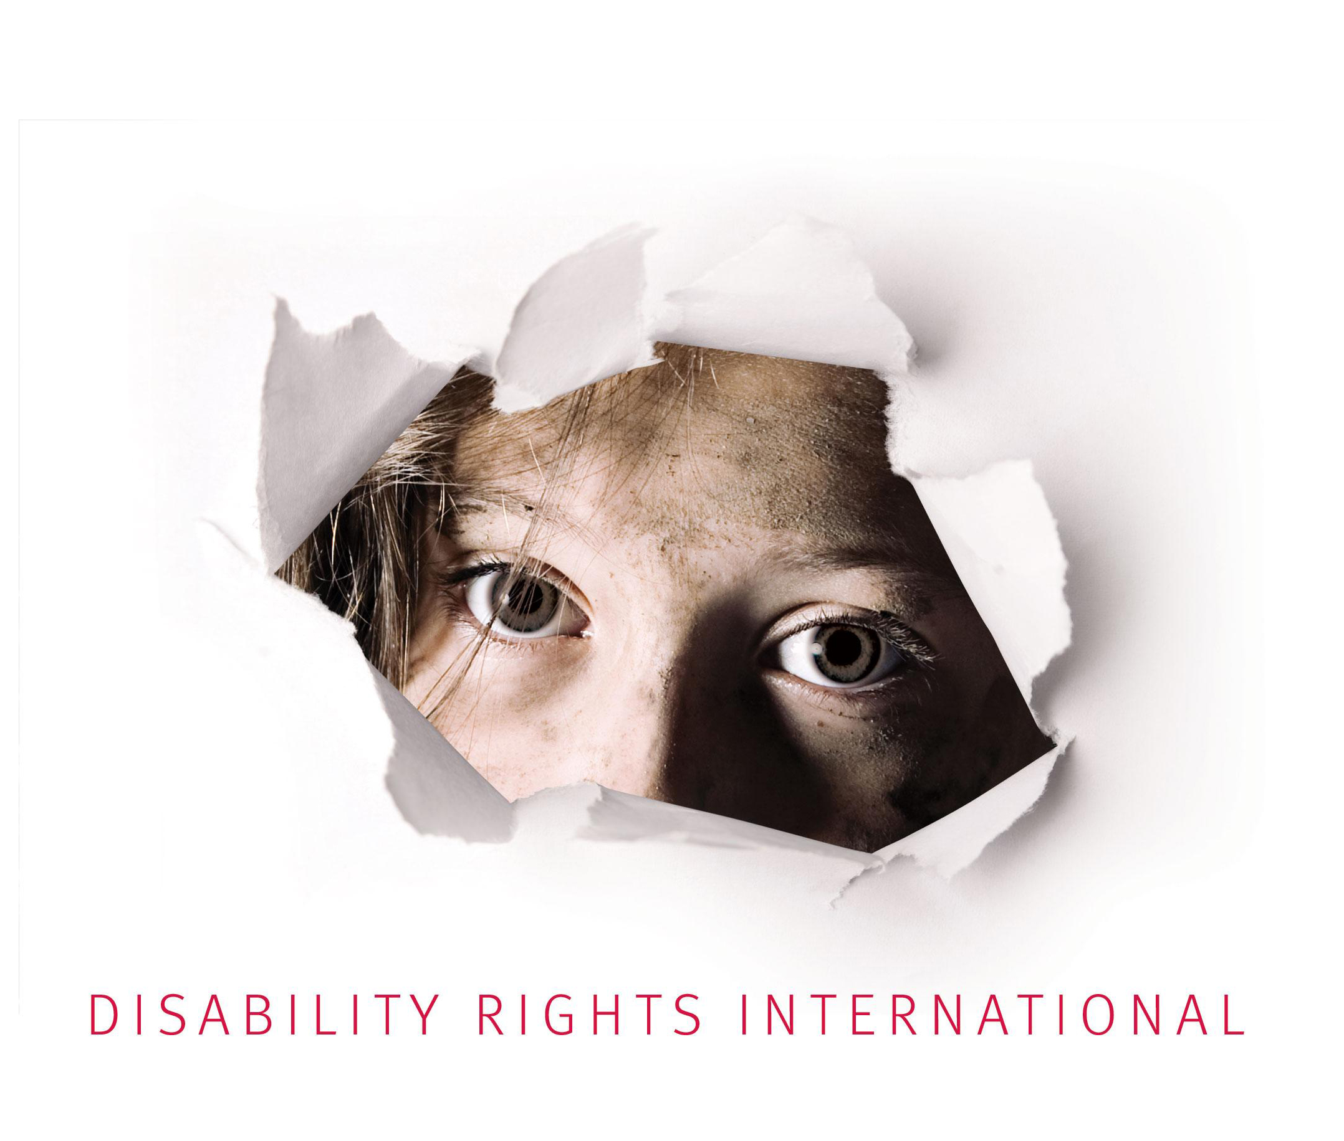

Comments and suggested revisions to the UN Committee
on the Rights of Persons with Disabilities

Draft General Comment No. 5

On the right of people with disabilities to live independently

Submitted by: Disability Rights International
Washington, DC
June 30, 2017
Note: Recommended language to modify the Draft General Comment No. 5 follows this overview analysis.

- OVERVIEW ANALYSIS

Protecting children: DRI’s comments are intended to ensure that General Comment #5 responds to the special concerns of children segregated from society, the grave dangers to physical and mental health caused by institutional placement of children at a formative period of their growth and development, and the urgent need to create community services to prevent break-up of families and new placements. It is important to recognize the vast majority (80 to 98%) of children with and without disabilities who are placed in institutions or orphanages are not true orphans but have at least one living parent. Almost all children have extended families. DRI calls on the CRPD to adopt an even higher standard of care to ensure children the full enforcement of the right to live independently and in the community.

Core protection for children – right to a family: It is important for the CRPD Committee to recognize the different approaches to protecting the right to independent living rights for children and adults. For adults, the greatest risk is institutionalization which entails the loss of freedom and autonomy. For children, especially at young ages, there is a greater need for family support and stable emotional bonds. The CRPD Committee notes the importance of the “evolving capacity” of children – something that develops over time with the proper support. For children to develop the emotional and cognitive abilities to take full advantage of the right to live independently in the community, family protection is essential from an early age and continuing through adolescence. Thus, the core element of living in the community for children is not just the protection from institutionalization but the affirmative support for living with a family. Many other living arrangements may exist in the community, such as group homes, small institutions, or so-called “family-like” institutions. But the scientific literature powerfully demonstrates that these are no substitute for the essential need of all children to grow up with a family. The CRPD Committee should emphasize the essential link between article 19 and article 23(5) which takes a strong stand on the right of children to grow up with a family and not any form of institution.

CRPD provides stronger protection than CRC: At the time that the Convention on the Rights of the Child (CRC) was drafted, it was assumed that some children with disabilities needed to be in institutions. Thus, article 20 of the CRC states that when children are unable to live with their parents, they may be placed in “suitable institutions.” CRC art. 23 implicitly recognizes this limitation when it calls for governments to provide services “conducive to” a child’s with disability “fullest possible social integration” – leaving open the idea that complete integration might not possible for some children with disabilities. The CRPD moves away form a medical model approach that just promises services in the community and instead guarantees the outcome: the right to live and be included in the community. And to implement this right, the CRPD Committee has made clear in other parts of this general comment there is no need for any person to be placed in an institution because of a disability.

The CRPD Committee should make it clear that there is no institution that is “suitable” for children with disabilities. A growing number of places in the world have entirely phased out institutional placement for children. If children are to remain in institutions, it is a reflection of a State Party’s failure to create the necessary supports for families and extended kinship care.

Ending institutional placement: General Comment #9 on the CRC limits institutional placement to the “last resort.” While this standard can be valuable in reigning in policies that actively support institutional placement, it provides little or no protection to children with disabilities where community services have not been created for them. As a result, institutional placement often ends up being the only option for children with disabilities and, instead of being a “last resort”, it becomes the common practice for them. The CRPD Committee has taken a strong stand by calling for ending or “abolishing” institutional placement of children as part of the State’s obligations to fully guarantee the right of children with disability to live and be included in the community. This is reflected in the CRPD Committee’s country reviews on the Czech Republic and Guatemala. DRI’s comments are intended to re-affirm those recommendations so that the CRPD Committee can ensure that they are included in its General Comment 5.

Protecting children now in institutions: For children already placed in institutions, and until such time as community services are created, CRC General Comment #9 follows the CRC mandate to create “suitable institutions” by calling for “transforming” these facilities into “family-like” environments. This approach would encourage new investments in institutions rather than using limited funds to protect families, and it risks reinforcing segregated service systems. As Save the Children has pointed out, “[t]he very existence of institutions encourages families to place their children into care and draws funding away from services that could support children to thrive within families and communities.” The CRPD Committee and has taken a strong stand on this issue calling for international aid and funding not to be used to fund institutionalization and improve institutions, but rather, independent living, in accordance with Article 32 of the CRPD. The UN Office of the High Commissioner for Human Rights (OHCHR) has also issued a similar recommendation.

Former UN Special Rapporteur on Torture Juan Mendez’ recent thematic report on the protection of children against torture in detention provides valuable analysis and recommendations for protecting children in detention. The Special Rapporteur notes that placing any child in an institution puts them at “heightened risk” of being subject to ill-treatment or torture. Thus, The Special Rapporteur recognizes that the obligation to create services to prevent improper institutionalization is a requirement of the Convention Against Torture. If children are placed in institutions as a last resort because no other services are available, the Special Rapporteur requires that they be placed “in the least restrictive environment” and “for the shortest time possible.”

These are stronger protections than those recognized by CRC General Comment #9 or by the UN Guidelines on Alternative Care for Children. While the UN Guidelines call for planning to “eliminate institutions” they do not require that out-of-family placement be for the shortest time possible. The UN Guidelines state that all children in the 0-3 age group should be with families and not in any form of institution, group home, or residential care. At older ages, however, they accept that children may be placed in “residential” facilities – such as group homes. The CRPD Committee has properly taken a stand against the use of group homes and other smaller institutions for adults. This position is even more important for children. It is imperative that the CRPD Committee notes the increased protections created by the CRPD and the need to harmonize all CRC interpretation, including General Comment #9 and the UN Guidelines, with the protections established under the CRPD.

- PROPOSED ADDITIONS TO THE DRAFT GENERAL COMMENT NO. 5

Para 1: Insert at end of first paragraph: “For children, the right to community inclusion requires opportunity to grow up with a family (biological, kinship, or foster family). For all children with and without disabilities, growing up with a family is essential to develop the emotional skills needed for full and effective participation in the community as an adult. Placement in any form of institution is emotionally dangerous for children, leaves to developmental delays, and exposes them to increased risk of abuse, neglect and violence.”

Para 11 add to end of paragraph or insert new paragraph: “Article 20 of the CRC states that children unable to remain with their family may be put in “suitable” institutions. The CRC must now be interpreted in light of important new developments under the CRPD which does not allow for institutionalization of any kind. General Comment #9 of the Committee on the Rights of the Child must be revised accordingly. General Comment #9 allows for placement of children with disabilities in “suitable institutions” and calls on states to “transform” them into “family-like” facilities. As specified in CRPD article 23(5), where the immediate family is unable to care for a child with disabilities” States are required to “undertake every effort to provide alternative care within the wider family, and failing that, within the community in a family setting.” Article 23 recognizes no possibility for placement in “suitable institutions.” Indeed, research shows that small institutions, group homes, or “family-like” institutions are no substitute for an actual family.”

Para. 15(c) insert at end of paragraph: “Large or small group homes are especially dangerous for children, for whom there is no substitute for the need to grow up with a family. “Family-like” institutions are still institutions and are no substitute for care by a family. For children, it must be understood that the stable and nurturing context of a family is essential to develop the psychological and cognitive skills necessary to grow up as an independent adult. International aid and funding should not be used to fund ‘family-like’ institutions and instead, should be used to fund community services and supports for children and parents with disabilities, in accordance with Articles 19, 23 and 32 of the CRPD.”

Para. 23 Insert at end: “Children without a specific label of disability are also recognized as rights-holders under article 19 and 23. Many children are placed in institutions because their parents are deemed to have a disability or be incapable of raising them. Failure to create community-based services and supports for families will result in the denial of rights to such children. Given the emotional trauma of family separation and the emotional, cognitive, and developmental damage that may be caused to children through institutional placement, all children are protected against institutionalization under the CRPD. It is especially important to protect children in institutions and afford them with rights under the CRPD because their disabilities may be invisible. Article 23(4) explicitly applies to all children who have a right not to be separated from their parents because of a disability of the child or parent, and this right also extends to the rights protected under article 19.”

Note: The relevance of the CRPD to non-disabled children is implicitly referenced in PARA. 84 but further clarification would be helpful. Para. 84 is not explicit that children without disabilities are rights-holders under the CRPD.

PARA. 28 insert at end: “For children, support for residential services in the contact of a family, kinship care, or substitute family may be needed to allow for community inclusion. The term ‘residential’ services should not be used to justify group homes, small institutions, or “family-like” institutions which are inappropriate for children and do not comport with the right to community inclusion.”

Para. 40 add to end: (e) “For children, the core of the right to live and be included in the community entails a right to grow up in a family.”

Para 73 INSERT: after “children with disabilities” the words “as well as children without a disability label.“ Article 23(4) protects children with and without disabilities from separation based on the disability of the parent or the child.

Para. 84 INSERT at end of first sentence: “These rights also protect children without disabilities who may be taken away from their families because of real or perceived disability of their parents.” INSERT AT END OF PARA 84: “Article 23(5) is also linked with the right to community inclusion under article 19. Article 23(5) commits governments to make every effort to ensure inclusion within a family or, failing that, ‘within the community in a family setting.’ A ‘family setting’ is not the same thing as a ‘family-like institution,’ which is simply another form of institution. It is paramount under article 19 and 23(5) that children have a right to grow up with a family where emotional bonds over time are established. Only through enforcement of a right to grow up with a family will children develop the skills needed to live independently in the community as adults.”

Para. 94(d) INSERT AT END OF SENTENCE: “given the special dangers of placing children in institutions, states should establish a moratorium on new placements of children in institutions. Children already placed in institutions should only be kept there for the shortest time possible until family-based alternatives can be created. All children of ages 0-3 must be placed in a family setting as even short-term institutionalization can be dangerous for them.

For further background and legal analysis of these issues, see Eric Rosenthal, “A Mandate to End the Placement of Children in Institutions and Orphanages: The duty of governments and donors to prevent segregation and torture,” in Protecting Children Against Torture in Detention: Global Solutions for a Global Problem (Juan Mendez, ed., 2017). Posted at http://antitorture.org/wp-content/uploads/2017/03/Protecting_Children_From_Torture_in_Detention.pdf
Richard Carter, Family matters: A study of institutional childcare in Central and Eastern Europe and the former Soviet Union 1 (Every Child, 2005).
The Better Care Network, “Global Facts about Orphanages” (2009), p. 1. Available at http://handstohearts.org/wp-content/uploads/2011/04/Global-Fact-Sheet-on-Orphanages_BetterCareNetwork.pdf
See Eric Rosenthal, supra nota 1.
As the European Office of the OHCHR stated: “…the wording ‘in suitable institutions’ needs clearer interpretation to avoid misuse as a justification for institutional care. The CRC was drafted during the 1980s, when the issue of institutionalization was not perceived as one of the most serious concerns. The then-Communist countries of Eastern and Central Europe, where institutional placement of children was part of the ideology governing child-protection systems, were among its active drafters. Therefore, it is understandable that an elastic definition of ‘suitable institutions’ might have represented the lowest common denominator in that geopolitical situation….Today, more than two decades after the adoption of the CRC, it is appropriate to raise the question of whether institutional care can be a “suitable option” for children at all, especially for children under three years of age; whether any exceptions are acceptable; and whether it is time to seriously consider its elimination.” United Nations Office of the High Commissioner on Human Rights, Regional Office for Europe, The Rights of Vulnerable Children Under the Age of Three: Ending their Placement in Institutional Care, 10-11 (2011) (hereinafter “Europe Regional Office of the OHCHR (2011)”).
Researchers have called into question the difference between large and small institutions, noting that even placement in small residential facilities can cause emotional and developmental dangers Mary Dozier, Joan Kaufman, Roger Kobak, Thomas G. O’Connor, Abraham Sagi-Schwartz, Stephen Scott, Carole Shauffer, Judith Smetana, Marinus H. van IJzendoorn, and Carles H. Zeanah, Consensus Statement on Group Care for Children and Adolescents: A Statement of Policy of the American Orthopsychiatric Association, 84 American Journal of Orthopsychiatry 219, 220 (2014).
Nigel Cantwell, Jennifer Davidson, Susan Elsley, Ian Mulligan, and Neill Quinn, Moving Forward: Implementing the ‘Guidelines for the Alternative Care of Children 43 (Centre for Excellence for Looked After Children in Scotland, 2012) [hereinafter Implementing the Guidelines]. See also Ministry for Foreign Affairs Sweden, Children in Institutions: International Development Cooperation, 2001, available at http://www.government.se/contentassets/42b806a7f8b046468116e4f1245428b5/children-in-institutions (last visited Nov. 16, 2016); Kerryn Pollock, Children’s homes and fostering - Foster care and family homes, Te Ara - the Encyclopedia of New Zealand, http://www.TeAra.govt.nz/en/childrens-homes-and-fostering/page-4 (last visited Nov.16, 2016).
UN Committee on the Rights of the Child, General Comment No. 9 (2006): The rights of children with disabilities, February 27, 2007, CRC/C/GC/9, para.47 [hereinafter “General Comment No. 9”].
See, e.g. Disability Rights International, The Exclusion of Children and Adults with Disabilities from Reform and Rights Protection in the Republic of Georgia (2013). Posted at www.DRIadvocacy.org. An ambitious plan to close down all institutions for children in Georgia was widely touted as a great success. But children with disabilities remain to this day in institutions as the “last resort” because of a failure to create community services.
CRPD/C/CZE/CO/1
CRPD/C/GTM/CO/1, para. 54
Corinna Csaky, Keeping Children Out of Harmful Institutions: Why We Should Be Investing in Family-Based Care, 2 (Save the Children, 2009).
CRPD/C/GTM/CO/1, paras, 74 and 75.
A/HRC/34/32 para. 61 (e)
UN Human Rights Council, Report of the Special Rapporteur on torture and other cruel, inhuman or degrading treatment or punishment Juan E. Méndez, UN Doc. A/HRC/28/68 (March 5, 2015), (hereinafter, the “Méndez 2015 Report” or “Report on Children in Detention”), at para. 21.
Id. at para. 16 “Children deprived of their liberty are at a heightened risk of violence, abuse, and acts of torture or cruel, inhuman or degrading treatment or punishment.”
Id.at para. 72.
UN General Assembly, Guidelines for the Alternative Care of Children, GA Res 64/142, UN Doc. A/RES/64/142, (February 24, 2010), para. 22 (hereinafter “Guidelines for Alternative Care” or “the Guidelines”).
The Guidelines state that “[r]emoval of a child from the care of a family should be seen as a measure of last resort and should be, whenever possible, temporary and for the shortest possible duration.” (para.13) [emphasis added]. This limitation is very important. But as drafted, the limitation on time applies only to removal from the family and not to placement itself. Once family ties have been broken or no longer exist, the Guidelines to not limit the time of placement in an institution or in residential care. Overall, social services must be reform and governments must move toward “progressive elimination” of institutions (para. 22) in a “timely manner” (para. 23). Under the Guidelines, children may be placed in long-term residential care facilities indefinitely. Residential placement is accepted as a necessary “complement” to family-based care. For further concerns about the Guidelines, see Eric Rosenthal supra nota 1.
A/HRC/34/32 para. 30
Eric Rosenthal, “A Mandate to End the Placement of Children in Institutions and Orphanages: The duty of governments and donors to prevent segregation and torture,” in Protecting Children against Torture in Detention: Global Solutions for a Global Problem (Juan Mendez, ed., 2017). Posted at http://antitorture.org/wp-content/uploads/2017/03/Protecting_Children_From_Torture_in_Detention.pdf
CRPD/C/GTM/CO/1, paras, 74 and 75.
The United Nations Study on Violence against Children (UNVAC Study) found that the long-term effects of institutionalization could include severe developmental delays, disability, irreversible psychological damage, and increased rates of suicide and recidivism. U.N. General Assembly, Report of the Independent Expert for the United Nations Study on Violence against Children, Paulo Sérgio Pinheiro, paras 53, 54, U.N Doc. A/61/299 (Aug. 29, 2006).
A/HRC/34/32 para. 58; CRPD/C/CZE/CO/1; CRPD/C/GTM/CO/1, para. 54
A/HRC/28/68 para 72

