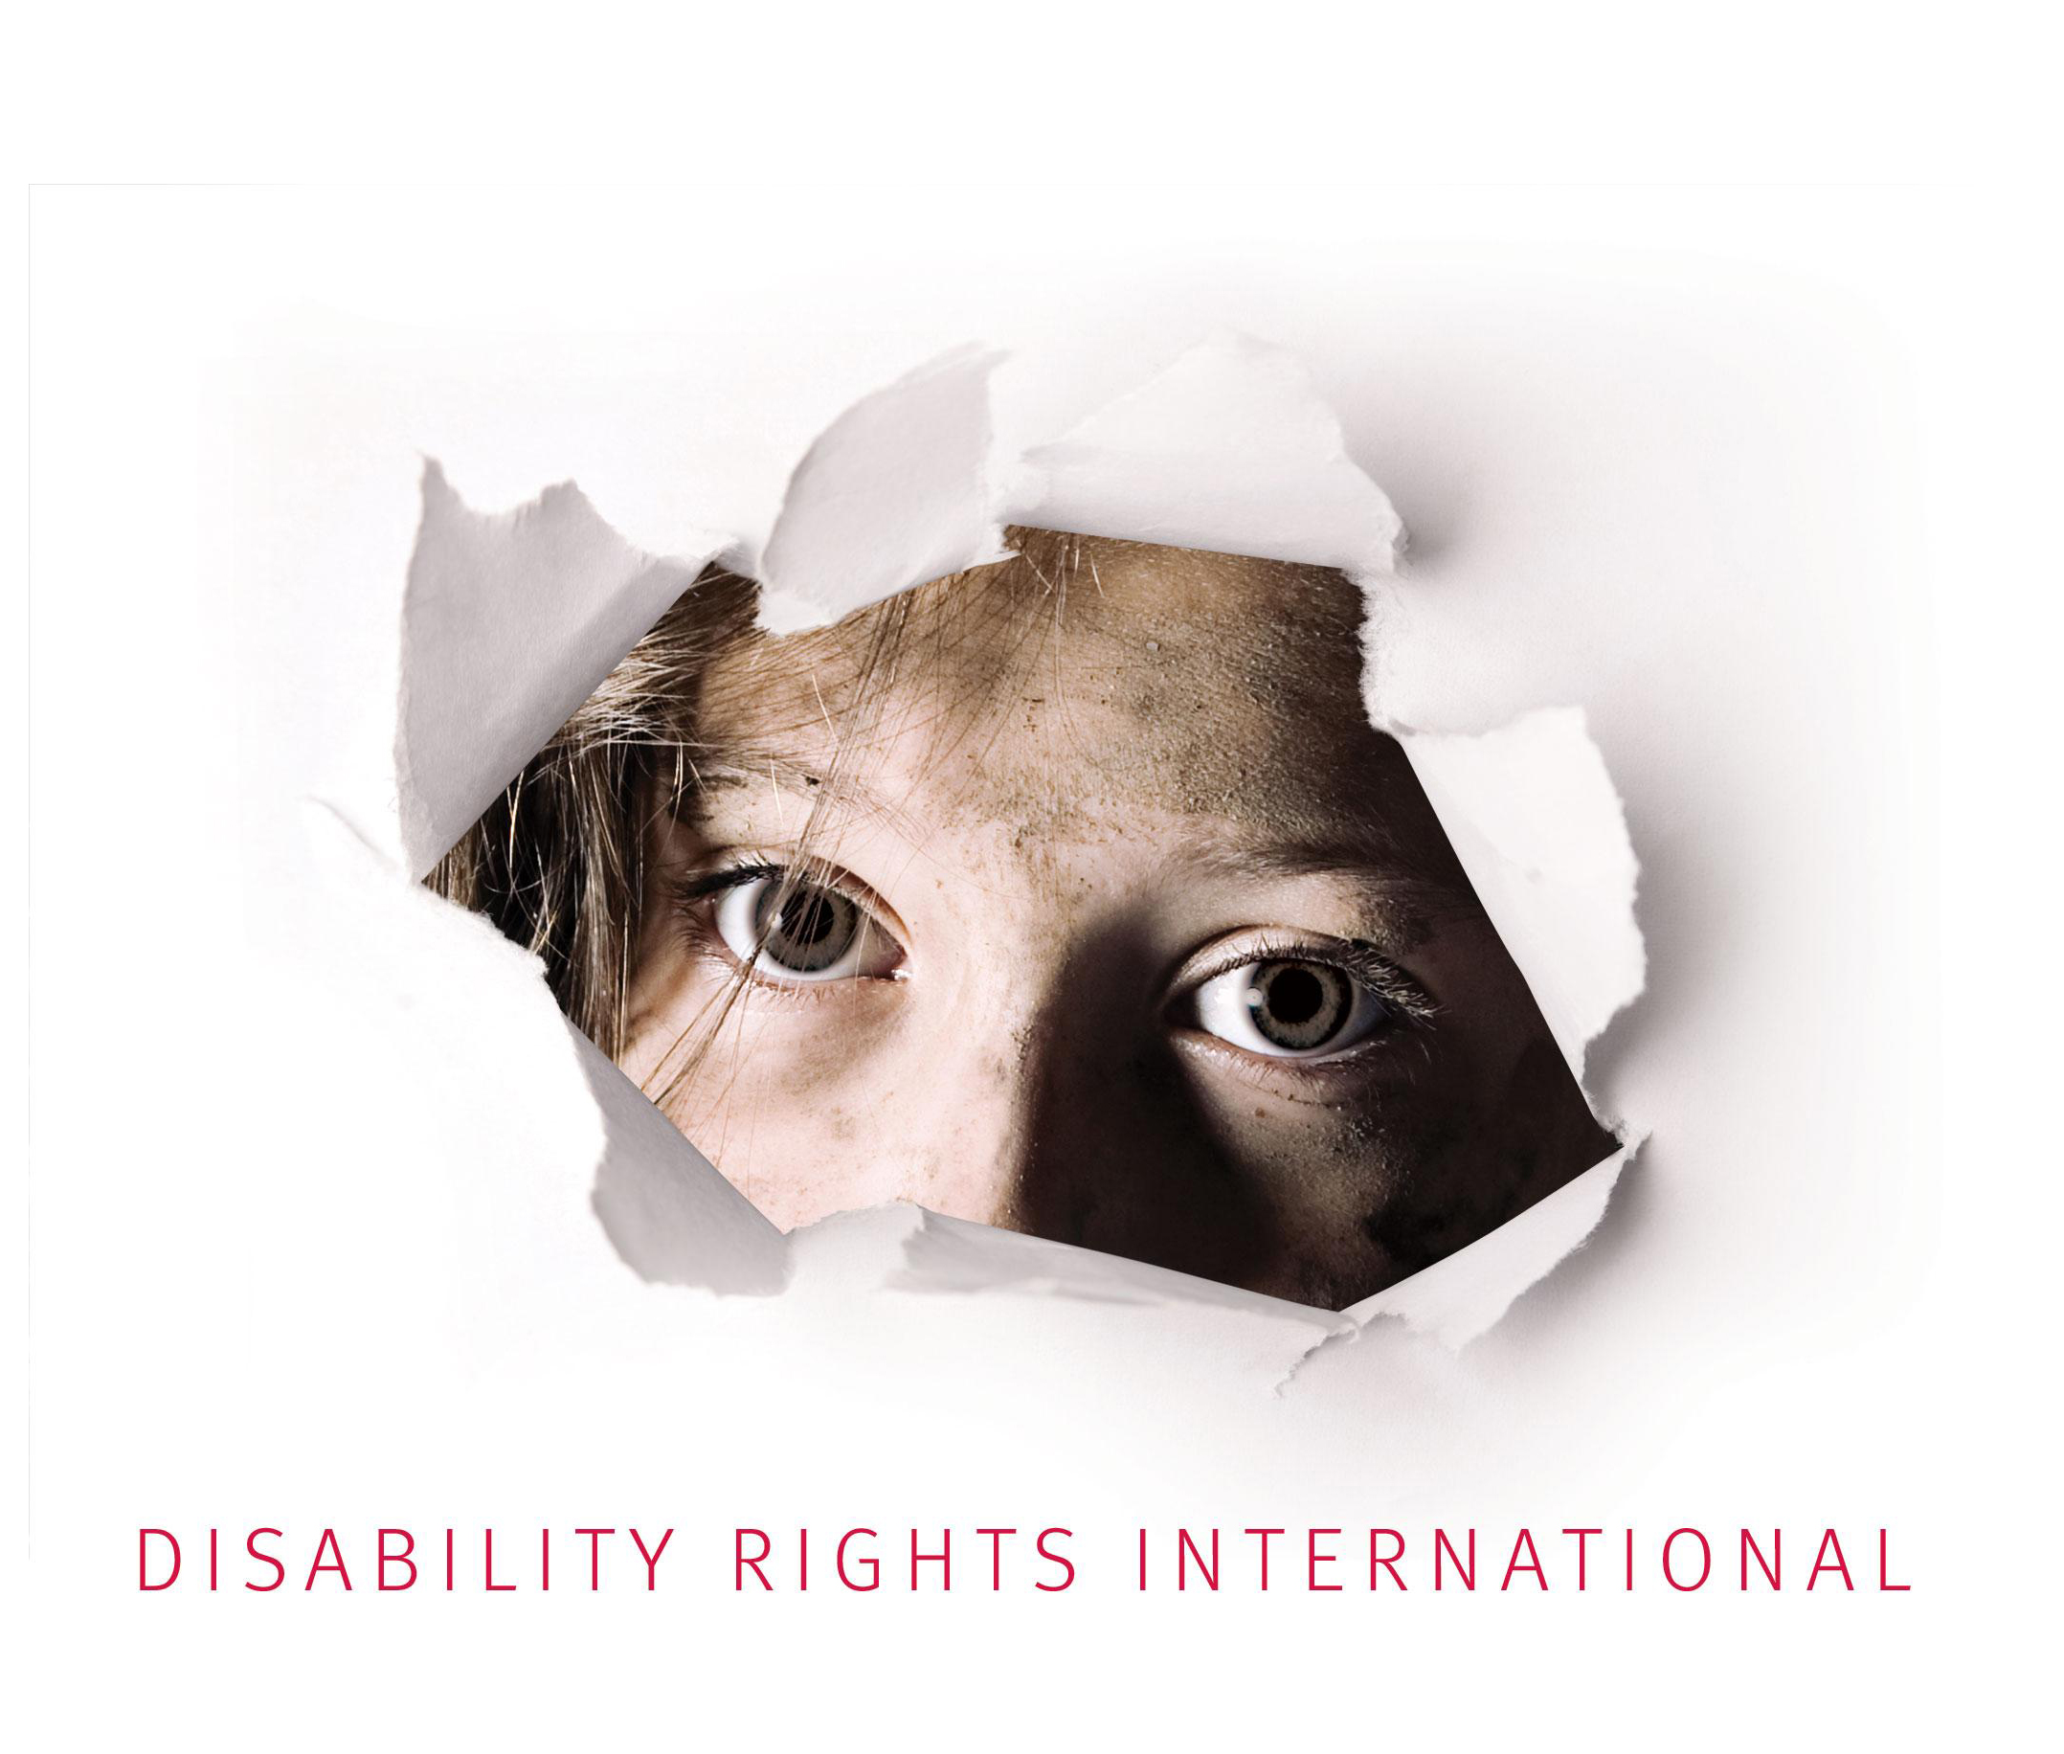

Comments to the UN Committee on the
Rights of Persons with Disabilities

International Aid Funds Institutionalization in Guatemala

Submitted by: Disability Rights International
Washington, DC

INTERNATIONAL AID FUNDS INSTITUTIONALIZATION IN GUATEMALA

CRPD Question:

International Cooperation: Guatemala has the presence of several international aid agencies how are persons with disabilities being considered in their programs? And how is it interfering with their right to live in the community?

- Summary

We have consistently found that international cooperation and government funding in Guatemala are not being used to guarantee the right of persons with disabilities to live in the community through the creation of alternatives to institutions and supports to persons with disabilities and their families to be able to remain in the community. In fact, this funding often goes to funding institutions where children and adults with and without disabilities are permanently segregated. Particularly worrying is the rise of “voluntourism” which is fuelling institutionalization. Voluntourism consists in tourist that are travelling to a certain country and want to get involved in some type of services that they combine with their trip. Voluntourism is increasing in many parts of the world, especially in relation to orphanages and institutions where tourist pay to volunteer for a short period of time. DRI documented the case of Esperanza de Vida, an institution that charges volunteers USD $600 per week to come and stay with the children. According to the Director’s institution, it largely depends on these fees to sustain an orphanage for children with and without disabilities.

- Context

Guatemala, classified as a lower/middle-income country, is the most populated country in Central America with one of the highest demographic growth rates. It has the largest proportion of indigenous population in Central America (over 40%) and 52% of the total population is younger than 20 years of age. Guatemala’s public finance management is the major issue, being the country in Latin America with the lowest tax revenue to GDP ratio (12%). For all these reasons and more, many international agencies are present and provide assistance to improve the current state of the country. Among these, there are the European Commission, as a principle international donor (€186 million); United States Agency for International Development (USAID); Spanish Agency for International Development Cooperation; Japan International Cooperation Agency (JICA); Swedish International Development Agency (SIDA); and, The United Nations System (Unicef, etc).

Most of the funding is focused on ensuring democratic human security, enhancing the rule of law and reducing impunity through reform of the justice system, reducing structural economic and social inequality and discrimination, guaranteeing the respect of human rights, in particular for the indigenous people, women and children, and combating widespread poverty and malnutrition, in particular in rural areas. These programs are not specifically oriented towards or take into consideration the rights of person with disabilities event though they suffer the most perverse forms of discrimination, as well as difficult life conditions, compared with any other vulnerable group of society. According to a recent report published by the SIDA, over two million people live with some kind of disability in Guatemala, equivalent to around 13% of the population (15.47 million in 2013). Disability is both a cause and consequence of poverty: only 15% of people with disabilities in Guatemala are estimated to have an income; 13% are occupied within the informal sector and only 2% have a formal employment according to the National Council for the Attention to People with Disabilities (CONADI).

Disability is a source of impoverishment both to the persons with disabilities and their families. Poverty dimensions in Guatemala are as elsewhere gendered and enhanced by racial discrimination, which is reflected in the life of persons living with disabilities. The National Institute of Statistics (INE) informs in the report Mujeres y Hombres en cifras 2008, that 66% of the persons with disabilities in 2005 were indigenous. They are highly overrepresented given that approximately 40% of the citizens belong to indigenous populations. The report shows that almost 60% of the women and 45% of the men with disabilities in the country have never enrolled in school, approximately 15% of the girls and 20% of the boys with disabilities had completed year 4 to 6 of the primary school and less than 5% attended secondary school (2005).

Despite the aforementioned, in general disability rights tend to be framed in isolation and are not raised when rights to gender equality, education, health, housing, social protection, sexual and reproductive rights for instance are discussed. Given the serious human rights situation in the country disability rights seem to be overshadowed by other forms of discrimination and are rarely considered in national social programmes or in international donor programs. Due to a lack of governmental and international support with regards to the rights of persons with disabilities, there is a lack of rehabilitation or community-based services for persons with disabilities. Such people are arbitrarily and unnecessarily segregated from society in psychiatric institutions, where they are abandoned for life and are subject to cruel, degrading treatment or torture. One extreme example is the sexual, physical and psychological violence committed by inmates, armed guards and other staff against children and adults with disabilities at the psychiatric Federico Mora Hospital. Such isolation and the lack of community-based support are against article 19, the right to live in community, of the CRPD.

- International aid and voluntourism are funding institutions in Guatemala

  - Voluntourism

Volunteering in orphanages has become a hugely popular way to “give back” when travelling abroad. Placements can be organised in many ways - including through travel agencies, NGOs, churches and mission’s groups, schools and universities, as well as directly with orphanages themselves. However, voluntourism in residential care centres is financially contributing to the institutionalization of children, preventing the development of community integration and family placement. More and more orphanages are becoming businesses generating income from people willing to volunteer their time and donate their money.

No matter how clean and modern an orphanage, growing up in residential care can have a negative impact on children’s health, development, and life chances. Research has shown that children develop better in a family environment and that long-term institutionalisation is harmful to their cognitive, emotional, and social development. Thus, children that are segregated in institutions are more likely to develop a disability and for those who already had a disability, their disability is likely to worsen. For this reason, international standards have shifted away from providing support to children in institutions, to supporting instead children in a family environment. However, in many countries the out-dated model of institutionalization remains prevalent, and most of their funding arises from international aid and voluntourism.

An increase in the number of institutions in a country indicates an increase in the separation of children and families. Volunteering in such settings supports this trend. The more funding that goes toward institutions, the more appealing they become for struggling families, who become convinced their child will have a better future in the centre than at home.

Voluntourism and international funding is encouraging institutionalization in Guatemala and, in turn, discouraging the creation of programs and supports that allow children and persons with disabilities to live a family setting within the community. Most orphanages get their funding from international sponsorship and voluntourism and most are very accessible for donations through online platforms. In Guatemala we have found that there are several of these type of online platforms in Guatemala, below there are just some examples:

- Casa Guatemala is a registered NGO and receives no government funding. They rely on funds from individuals and groups around the world to provide care for up to 300 children at the institution. This institution also makes children work in their small business to get some income. http://www.casa-guatemala.org/
- Global Crossroad is a business registered in Dallas, Texas in 2003 and offers numerous abroad experiences to international volunteers in 18 countries located throughout Asia, Africa, and Latin America, including Guatemala. Global Crossroad has teamed up with local orphanages in Guatemala to offer volunteering opportunities for students abroad and help maintain children in these institutions. Instead of helping these children return to community and live with their families, most are kept in the institutions and depend on temporary international visits and sponsorships. http://www.globalcrossroad.com/guatemala/workinorphanage.php
- Volunteer HQ, another volunteer travel business offers the same kind of support to orphanages in Guatemala. They offer year-round programs in orphanages for volunteers. https://www.volunteerhq.org/volunteer-in-guatemala
- A broader View is another example of an international organization that helps the institutionalization of children in Guatemala. They offer volunteering projects at a government orphanage in the center of Xela, which also include many Mayan children from the next village who get separated by their families due to poverty and lack of community support. Though the organization and the participants have great intentions and want to help the community, the system and institutionalization has grave effects over the children who could otherwise take advantage of a care within their families or in the community. https://www.abroaderview.org/programs/orphanage-support/guatemala-orphanage-support

A recent article was published in Guatemala’s ContraPoder magazine, about an institution, Esperanza de Vida, which is focused in helping children facing malnutrition. The institution is created on a hill, isolated from community and mainly funded by international voluntourism. They require every volunteer to pay USD $600 per week to work within the institution. The government have also been supporting them, through the Ministry of Health -it gives them Q30 million, roughly USD 4 million. The institution has a hostel for volunteers, a hotel, an orphanage and an asylum. It still follows the model of an institution and keeps the people locked inside for life with no recourse to get out and into the community. Recently the government even provided more funding to transfer patients from the Federico Mora, only psychiatric institution in the country, to this institution. The foundation receives tremendous amount of money from international agencies and the government to hold the people locked within its borders, which is against their right to family and life in the community.

Historically, Guatemala has, for at least two decades, been harshly criticised for illegal adoption. Investigations have revealed that between 1997 and 2007, 26,203 children from Guatemala were abducted for illegal adoption in the USA, most from orphanages. Networks including different professionals –orphanage staff and lawyers – earned up to 50,000 US dollars per child. In trying to find a solution for this massive problem, a study was conducted by the President’s Office for Social Welfare in Guatemala with the support of Holt International Services and UNICEF in 2008 to analyze the situation faced by institutionalized children and adolescents in shelters in Guatemala. The main findings of the study were the following:

- 133 children’s shelters are operating in the country, of which the study was conducted in 127. 95% of the shelters are private and 5% are public, which demonstrates that the private sector is responsible for the vast majority of institutionalized children.
- There are a total of 5,474 children in institutions (1,925 in public institutions and 3,549 in private ones) and only 35% have a court order to be placed in residential care for protection purposes.
- Of the total number of institutionalized children and adolescents (5,600) at the shelters, 33% have been declared permanent shelter residents, in violation of their right to have a family.
- The majority of private shelters are unaware of minimum, internationally recognized standards for shelter operations.
- For 88% of shelters, the main source of funding came from private donations from international NGOs. 7% received their funding from churches or religious congregations and 5% received government funds.

According to this study, the Guatemalan system forces a large number of children and adolescents to have to live in institutions where there is no capacity to identify, locate and orient parents and family members on their duties, responsibilities and rights regarding child rearing, breaking the cycle of institutionalization. Every child has a right to a family; institutions should be temporary homes and not permanent ones. The study also shows that the legal status of 58% of the institutionalized children is pending because they don’t have a birth certificate or an identity, which is a violation of their right to an identity. This is due to the fact that almost 50% of shelters don’t have competent specialized personnel for the provision of integral care of minors nor orientation and training program to help children with their legal proceedings.

With pressure form UNICEF, the new Adoption Act was pushed through in 2008 by Congress and a national adoption agency was opened. The families throughout Guatemala now do not have to pay for adoption services. The current UNICEF project called "Developing a Child Protection System for Guatemalan Children and Adolescents" involves supporting institutions for children and young people, providing space for civil society, increasing the technical capacity and working with preventive measures. This also involves making the Adoption Act common knowledge and getting people to utilise it. SIDA is also contributing to UNICEF’s project in the amount of SEK 60 million to reduce child trafficking.

Though UNICEF’s main objective statement for their funding of the study and their involvement with Guatemala included prevention of institutionalization and de-institutionalization of children, their project is focused on the development of Child Protection System to protect children in institutions. They have been very successful in working with government and institutions to bring the Child Protection legislation forward, however most of their funding is oriented towards institutions (training, placement system, legal proceedings, etc), despite knowing that there is lack of community based alternative and foster family services. In the whole project document there is only one paragraph where they mention the “promotion of community support to vulnerable families”.

The legislative reforms regarding Child Protection might facilitate adoption, might reduce child trafficking, improve child conditions within institutions, which are very important improvements; but, it is difficult to assess, with the lack of alternative family and community services, how de-institutionalization of children might occur. More funding and recourses needs to be directed towards alternative care to assure the de-institutionalization and re-integration of these children within the community and a life in a family environment. However, in Guatemala the trend seems to still be towards institutionalization of children. With the lack of an effective foster family and community based services, children would still remain in institutions, mainly funded by international voluntourism, for life, which is against their right to a family.

Additionally, no attention is given to children with disabilities in neither of the UNICEF projects, private institutions or governmental programs. Persons with disabilities constitutes society’s most vulnerable group, their rights are often forgotten and they face extreme segregation and discrimination, especially with regards to adoptions. Institutionalization, by depriving children of close emotional relationships, can badly impair their capacity to make personal connections throughout their lives. It can slow their intellectual and emotional maturation and can erode their ability to make transitions from one development stage to the next. In fact, volunteers stay in institutions temporarily, helping the institution financially with their monetary contribution while developing relationships with these children and then leave. In consequence, children are left with feeling of abandonment again and again and never develop long-term relationships. This is even more problematic with children with intellectual or psychosocial disability, who require more care and attention as they might already face multiple levels of difficulty to make connections with people, resulting in their loss of trust and further segregation. There is also a lack of specialized personnel to take care of them and understand their needs.

- Conclusion

The international human rights law recognizes the family as the central nucleus for the protection of children and adolescents, as well as recognizing the right of children to live with their families. Specifically, Article 17(1) of the American Convention provides that “[t]he family is the natural and fundamental group unit of society and is entitled to protection by society and the State”; Article VI of the American Declaration expresses that notion in similar terms: “[e]very person has the right to establish a family, the basic element of society, and to receive protection therefore”. Further, permanent detention of children is a violation of Article 37 (b) of the Convention on the Rights of the Child. The UN Special Rapporteur on Torture has particularly noted that the deprivation of liberty of a child should be a last resort measure used only for the shortest possible period of time.

In 2010, the Committee on the Rights of the Child cited the need to de-institutionalize children in residential care. The Committee was concerned at the large number of children in institutions, as well as at the insufficient implementation of minimum care standards and monitoring systems for these institutions, especially at the placement of more than 1,000 children in a large institution (Hogar Solidario) in the capital. The Inter-American Commission on Human Rights further affirmed, in 2013, that the States are under the obligation, as part of their national protection systems, to create services that will allow children who were in residential institutions to reintegrate with the community.

However despite the IACHR affirmation, there is a major lack of alternative services to institutions. Most institutions are privately run and get their major source of funding from international voluntourism and cooperation, which encourages institutionalization. Due to a lack of support for families living in poverty and with increase number of institutions, families leave their kids in institutions thinking they will be better off there.

Despite the fact that the international standards call for the de-institutionalization of persons with disabilities and their integration within community through the adoption of article 19 of the Convention of Rights of Persons with Disabilities (CRPD), which stipulates the right to live independently and be included in the community, and article 14, which states that “the existence of a disability shall in no case justify a deprivation of liberty,” international cooperation and governmental funding is still directed towards institutions in Guatemala. The violation of the right to live in the community is particularly serious and one of the most severe forms of discrimination given that, by being segregated from society, a person looses all ability to exercise the other rights recognized in the Convention, including the right to education, a decent job, family, and others. Further, permanent detention of children is a violation of Article 37 (b) of the Convention on the Rights of the Child. The UN Special Rapporteur on Torture has particularly noted that the deprivation of liberty of a child should be a last resort measure used only for the shortest possible period of time.

Though Guatemala gets a lot of international support from many international organizations and agencies, most of these programs do not consider the rights of persons with disabilities within their objectives. Persons with disabilities are one of the most vulnerable groups in society who face multiple levels of discrimination and mostly segregated for life in inherently dangerous institutions. More attention and funding should be provided to people with disabilities as they represent 13% of the population, mostly live in poverty and there is a complete lack of support and community based alternatives to institutions in Guatemala. These people find themselves abandoned and without any recourse to justice or ways to improve their condition. Immediate attention and assistance is needed to improve their lives and recognize their rights and dignity, especially their right to live in the community.

Corte IDH, Ximenes-Lopes, p.12
Swedish International Development Agency (November 2014), Disability Rights in Guatemala, at p.1.
Instituto Nacional de Estadísticas (2008), Mujeres y Hombres en cifras 2008.
Disability Rights International (2012), Precautionary Measures in favor of the 334 people with mental disabilities interned in the Federico Mora Hospital, in Guatemala, in front of Inter-American Commission of Human Rights.
Guatemala ratified the CRPD in 2009 and endorsed the W.H.O.’s mental health plan in May. Yet the country allocates only about 1 percent of its modest national health budget to mental health, from which 94% goes to run its national psychiatric hospital. http://www.nytimes.com/2013/11/03/opinion/sunday/where-mental-asylums-live-on.html?_r=0
Better Care Network and Save the Children UK (
Nelson, C., Zeanah, C., Fox, N. (May 2009). The Effects of Early Deprivation on Brain Behavioural Development: Bucharest Early Intervention Project. Oxford University Press.; Tobias, D. Moving from Residential Institutions to Community-Based Social Services in Central and Eastern Europe and the former Soviet Union. The World Bank. 2000.
Sofia Menchu, Guayo Vargas, el Senor de los Milagros en Llano Verde, CONTRAPODER, Ano 3. Numero 140. Guatemala, 5 de febrero de 2016.
Swedish International Development Agency, “Adoption law reduces child trafficking”, Published 13 November 2012, available at: http://www.sida.se/English/where-we-work/Latin-America/Guatemala/examples-of-results/Angel-found-a-new-family-thanks-to-new-legislation/Facts-New-law-reduces-child-trafficking/ [last visited: 27 July 2016].
Adam Pertman (2011), “Adoption Nation: How the Adoption Revolution is Transforming Our Families –And America”, The Harvard Common Press, Boston, Massachusetts, at p.76.
National Adoption Council, 2013. The main reasons for placing children in residential care are family conflict, negligence, sexual abuse in the home, domestic violence, drug addiction and poverty. UNICEF. (2014) Guatemala- Country programme document 2015-2019. E/ICEF/2014/P/L.14, at para 13.
Ibid, at p.14
Ibid, at p.10
UNICEF, Developing a Child Protection System for Guatemalan Children and Adolescent, UNICEF Guatemala country program 2015-2019
SIDA, supra note 3.
UNICEF, Guatemala Country Program 2015-2019, para 27
Adam Pertman (2011), Adoption Nation: How the Adoption Revolution is Transforming Our Families –And America,The Harvard Common Press, Boston, Massachusetts, at p.77.
American Convention on Human Rights, article 17(1)
American Declaration of Rights and Duties of Man, article VI.
Report of the Special Rapporteur on Torture and Cruel, Inhuman or Degrading Treatment or Punishment, General Assembly,A/HRC/28/68( March 5, 2015), Juan Méndez, para. 72.
UNICEF. (2014) Guatemala- Country Programme document 2015-2019. E/ICEF/2014/P/L.14, at para 3. ; Committee on the Rights of the Child, Analysis of the Reports Presented by States Parties under Article 44 of the Convention. Concluding Observations: Guatemala, CRC/C/GTM/CO/3-4, October 25, 2010, para. 55.
The Inter-American Commission on Human Rights (2013), THE RIGHT OF GIRLS AND BOYS TO A FAMILY.ALTERNATIVE CARE. ENDING INSTITUTIONALIZATION IN THE AMERICAS, at para 553.
CRPD, art.19, 14.
Report of the Special Rapporteur on Torture and Cruel, Inhuman or Degrading Treatment or Punishment, General Assembly,A/HRC/28/68( March 5, 2015), Juan Méndez, para. 72.

